# Arduino RADAR Model using Ultrasonic Sensor for Detection

# 

# **Introduction**

In this project, we have designed Arduino RADAR Model using Ultrasonic Sensor for Detection & Ranging. RADAR is an object detection system that uses radio waves to identify the range, altitude, direction, and speed of the objects. The radar antenna transmits radio wave pulses that bounce off any object in its path. The object returns a portion of the wave received by the receiver which is in line of sight with the transmitter.

This Arduino RADAR project aims to achieve a radar system prototype based on an Arduino board, capable of detecting stationary and moving objects.

* **Materials**

|  |  |  |
| --- | --- | --- |
| S.N. | Components | Description |
| 1 | Arduino board | Arduino UNO R3 Development Board |
| 2 | Ultrasonic Sensor | 4X3 KeypadHC-SR04 |
| 3 | Servo Motor | SG90 Servo Motor |
| 4 | Breadboard |  |
| 5 | Connecting Wires | Jumper Wires |
| 6 | Processing-2.2.1 | Of 2014 |

**Arduino RADAR Model using Ultrasonic Sensor**

* Block Diagram

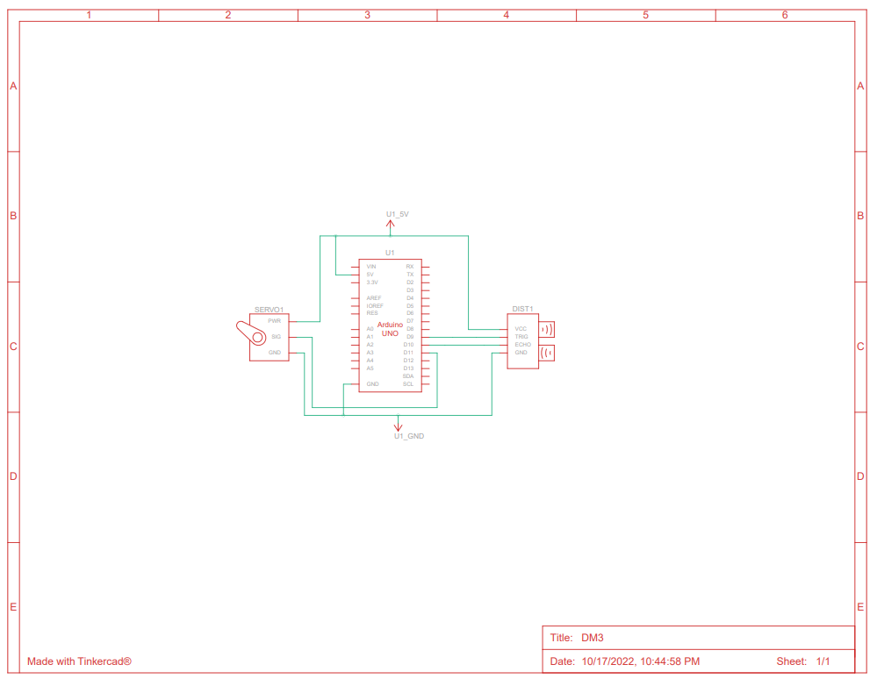

* Circuit Diagram

